WALMART CUSTOMER RETENTION ANALYSIS
Project Title
Walmart Customer Retention Analysis Using Power BI
Objective
The objective of this project is to analyze customer behavior, identify churn patterns, evaluate loyalty program effectiveness, and measure customer lifetime value (CLV). The project helps in understanding customer retention trends and provides actionable recommendations to improve customer engagement and business performance.
Task 1: Data Preparation and Customer Metrics
The customer and transaction datasets were imported, cleaned, and transformed in Power BI. Relationships were created between tables and key measures such as Total Customers, Repeat Customers, and Churned Customers were calculated.

Task 2: Churn & Retention Analysis
Customer churn and retention trends were analyzed across regions, income levels, and loyalty tiers. KPI cards and funnel charts were used to visualize customer retention performance.
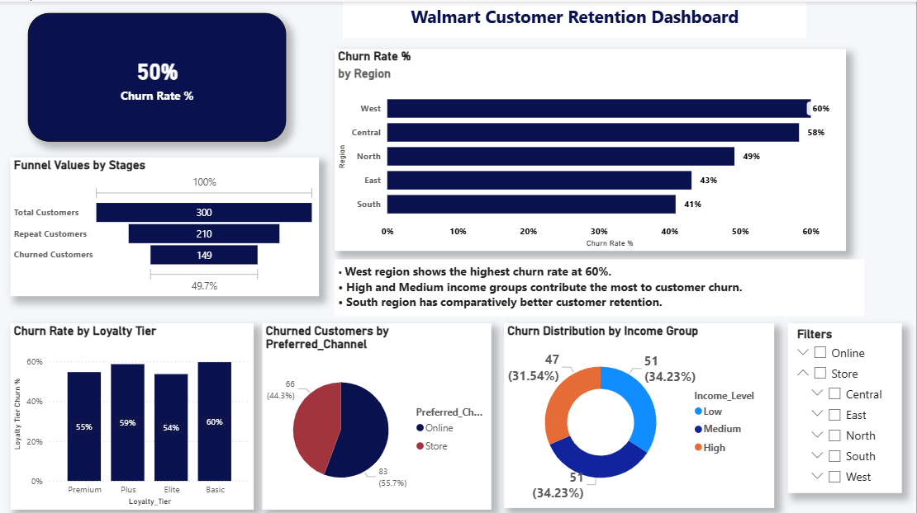

Task 3: Repeat Purchase Analysis
Repeat purchase behavior was analyzed based on age groups, regions, loyalty tiers, and purchase categories. Customer segments were identified to understand purchasing patterns.
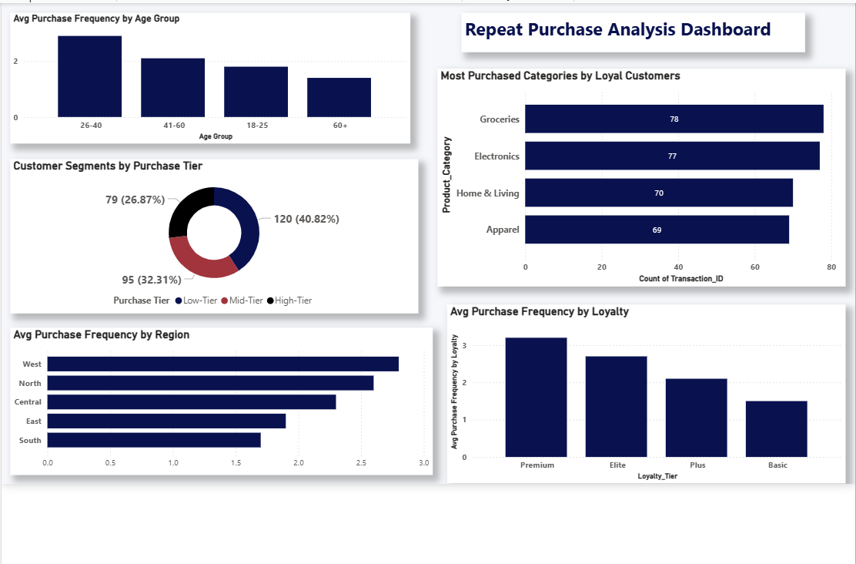
Task 4: Promotion & Loyalty Impact
The impact of promotions on purchase behavior was evaluated. Churn rates across loyalty tiers and points earned versus redeemed were analyzed to understand loyalty program effectiveness.
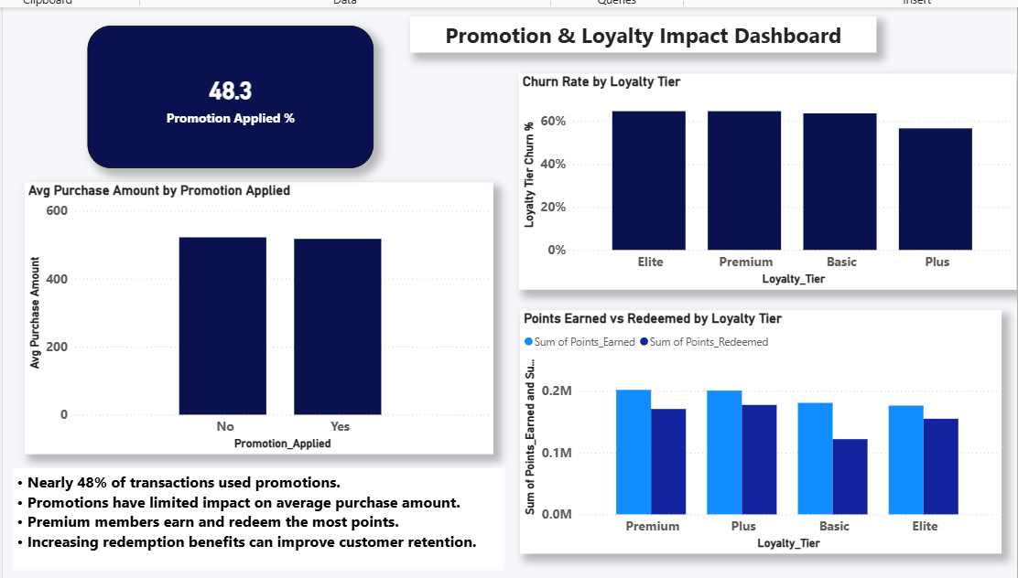
Task 5: Store & Channel Performance vs Retention
Store performance was evaluated using average transaction amount, churn rate by store type, and retention analysis based on store opening year.
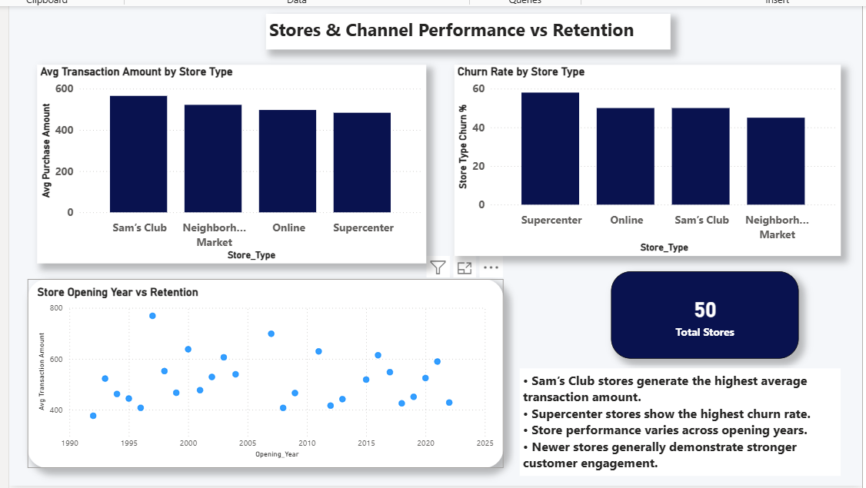
Task 6: Customer Lifetime Value (CLV) Analysis
Customer Lifetime Value was calculated and customers were segmented into High CLV and Low CLV groups. CLV was further analyzed across regions and loyalty tiers.
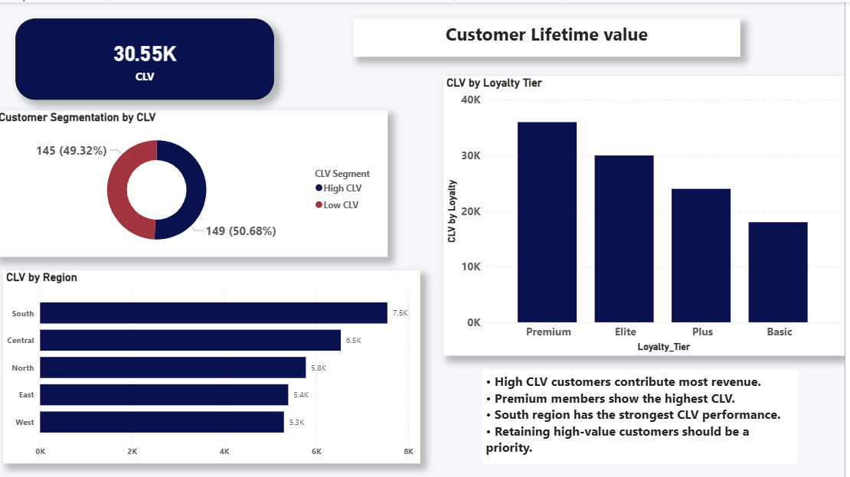

Final Dashboard & Executive Summary
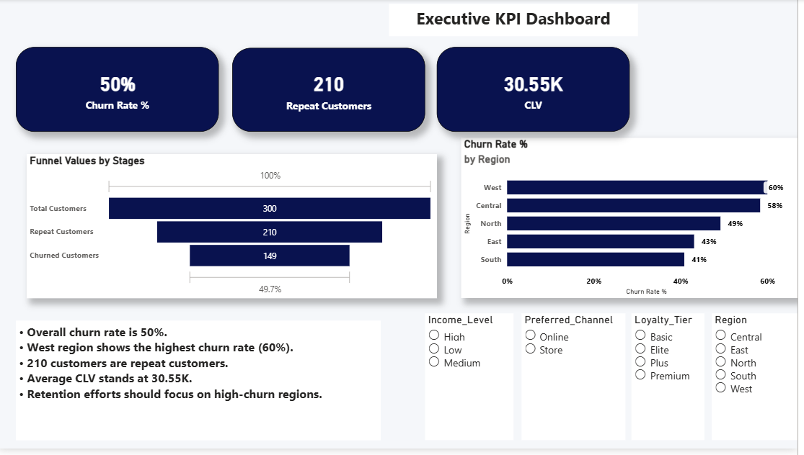
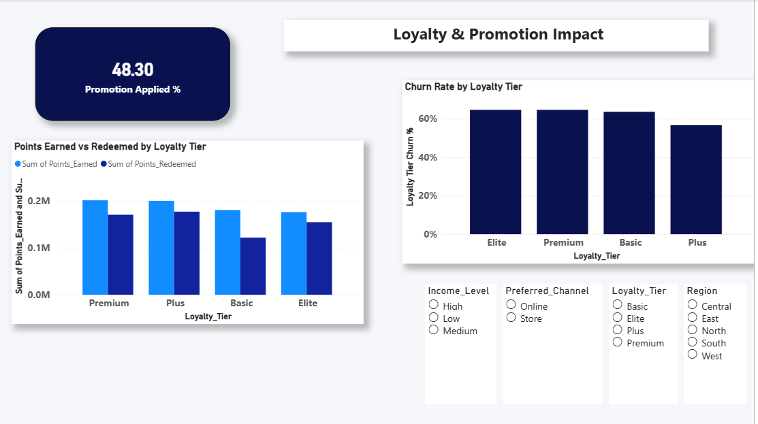

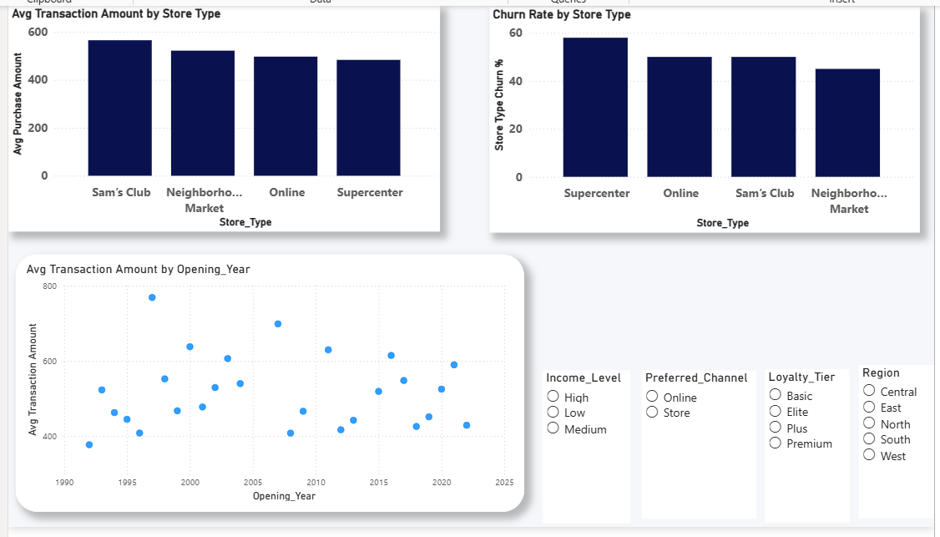
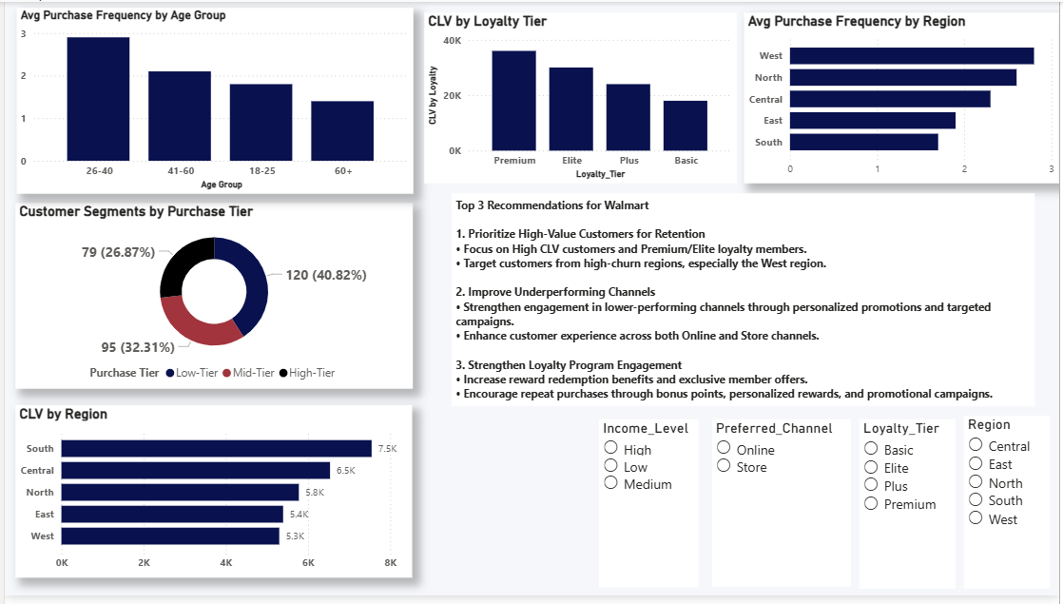
Key Findings
• Overall churn rate is approximately 50%.
• West region shows the highest churn rate.
• Premium and Elite loyalty members generate higher customer value.
• Nearly 48% of transactions used promotions.
• Loyalty program members earn and redeem significant reward points.
• South region generates the highest CLV.
• Repeat customers contribute significantly to overall business performance.

Top 3 Recommendations
- Prioritize High-Value Customers for Retention
Focus on Premium, Elite, and High CLV customers through targeted retention campaigns.
- Improve Underperforming Channels
Identify low-performing channels and increase engagement through personalized offers and promotional campaigns.
- Strengthen Loyalty Program Engagement
Increase reward redemption opportunities, exclusive benefits, and bonus point campaigns to encourage repeat purchases.
Video Explanation Link : https://www.loom.com/share/16f3deee0d4745dbaeb901dc02ecc6de
Conclusion
This project successfully analyzed customer retention, loyalty behavior, and customer lifetime value using Power BI dashboards. The insights generated can help Walmart improve retention strategies, customer engagement, and long-term profitability.

